What do we want from this plot?

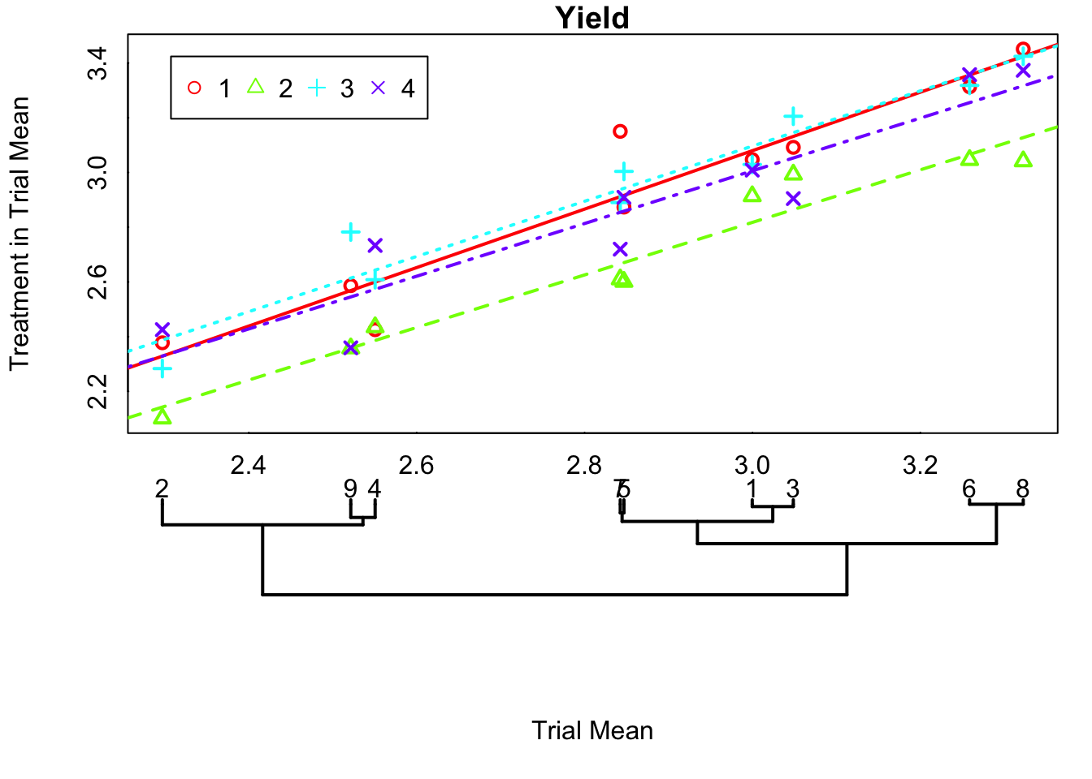
It should support and be supplemented by statistics
AOV
Mixed/REML
Mean Separation

Using REML confidence intervals, we find two estimates of treatment by trial coefficients that do not include 0.
Treatment2:TrialG
Treatment4:TrialG

